**CMP 4271: Session 4 Online Diary – Revitalising Noughts and Crosses**

**3.0 Introduction**

The aim of the game is to have four of your own symbol in a row.

The materials needed to play the game are a fair 4-sided die (number die) with numbers 1-4, a fair 6-sided die (the x/o die) with 3 sides displaying ‘x’ for crosses and the other 3 sides displaying ‘o’ for noughts, a pen and paper.

**3.1 Rules and How to Play**

* Draw out a 4x4 grid (Figure 1). Both players decide at the start of the game who will play as noughts and who will play as crosses, and who will take their turn first.
* For each turn, the players roll the x/o die to decide which symbol they will play for that turn. If a player is placing their opponent’s symbol, it would be advantageous to place their symbol in a place that would sabotage the opponent’s game.
* The number die determines the y-coordinate for where the player will place the symbol for this turn, but the player chooses the x-coordinate.
* If there is no square available in the row determined by the number die, the player misses their turn.
* The first player to get 4 in a row, column, or diagonal line wins.

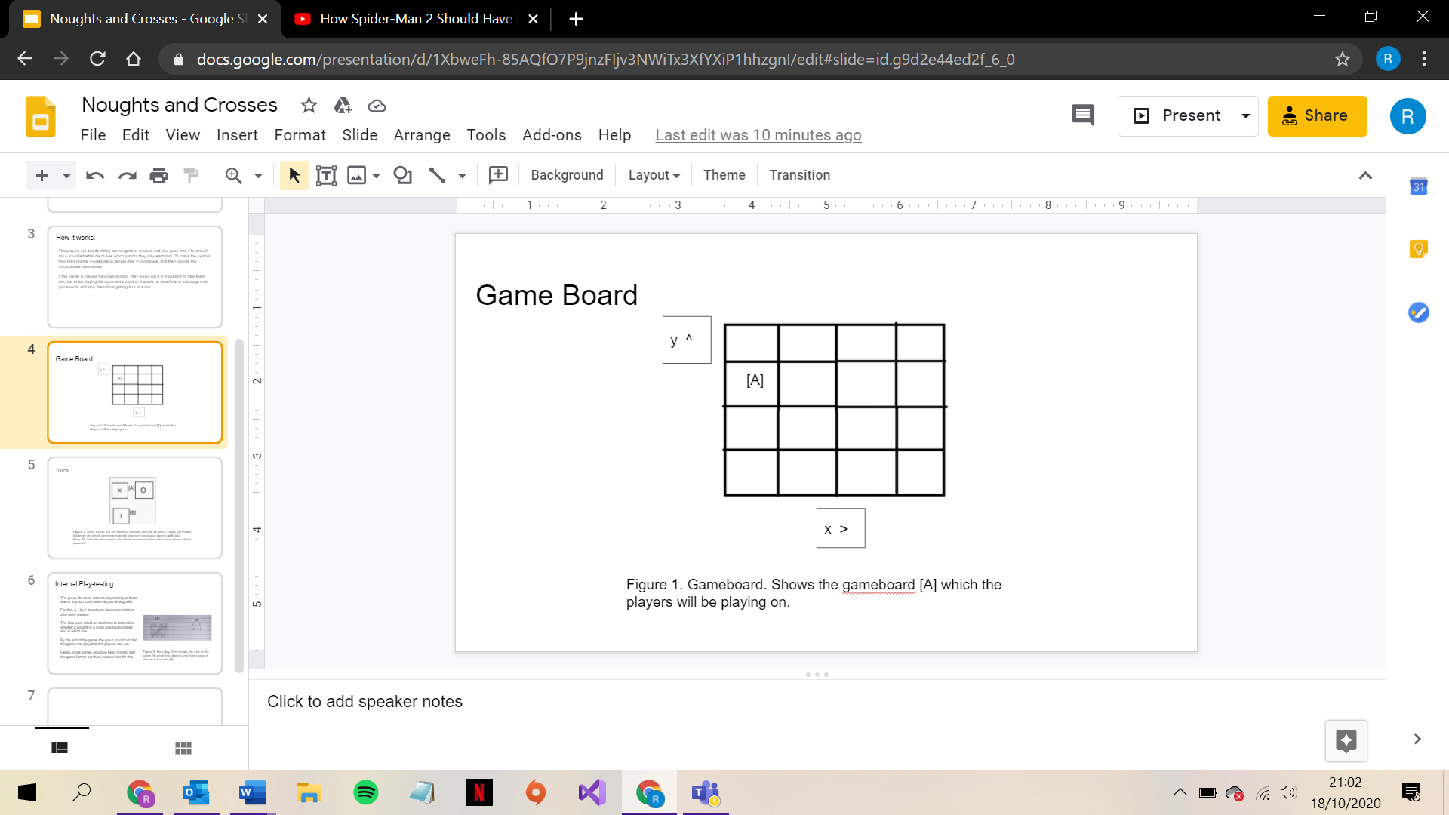

[A]

Figure 1. Shows the gameboard [A] which the players will be playing on.

**3.2 Play Testing**

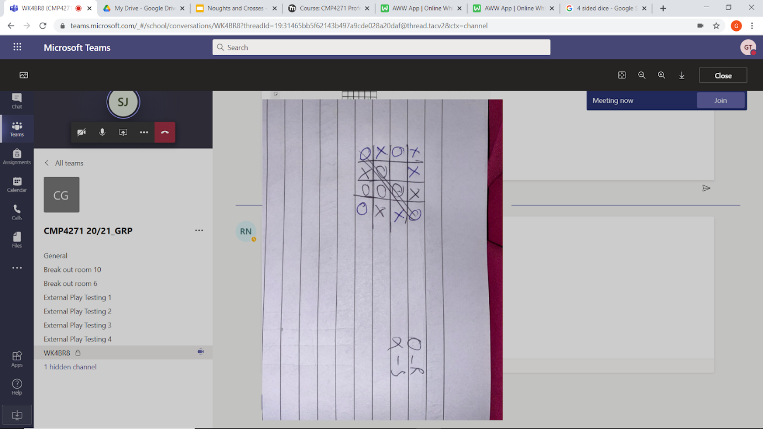No other teams responded to a request for play testing, so no external play testing was carried out. Instead, internal play testing was carried out (Figure 2), and it was found that the game was playable and understandable, but ideally more testing would have been carried out. Although, with internal playtesting, there is the possibility for bias when analysing the game. At this stage of testing, it was decided that any additional mechanics could make the game too confusing, therefore the game was not changed as a result of play testing.

Figure 2. Shows one game from internal playtesting.

**3.3 Working in a Team**

Figure 2. Showing the internal play testing carried out.

Having four members in the group was useful as it meant time could be spent more effectively. For example, two members carried out playtesting as the other two began to make the presentation. It also meant that the team could develop other members’ ideas to better suit the game. However, communication regarding ideas for game mechanics could have been improved, as some members had a different understanding of some mechanics to others.

**Team Members**

Sienna Jenkins

Giancarlo Trinidad

Stefan-Alexandru Zarnescu

Rowan Noble